PRACTICAL QUESTIONS FOR DATA VISUALISATION AND ANALYTICS (CIA1C11)
Practical 8 – Predictive Analytics I (Clustering)

Introduction: Assuming EDA and Data Preparation has been done for a dataset, and a fair amount of descriptive analytics has been generated. The next stage is to move into Predictive Analytics.

Predictive Analytics is an approach that uses statistical techniques to extract relationships from past data and use those relationships to (1) uncover hidden patterns and (2) make informed predictions about future outcomes. It has been blended with machine learning algorithms in recent years to improve the performance. Depending on the way these algorithms “learn” about the data, they can be categorized as supervised vs unsupervised learning.

In supervised learning, there is a target variable in mind to predict. The goal of supervised learning is to determine the “best” function such that when input variables are fed into the function, the model can predict the target variable well. One widely used algorithm of supervised learning is Linear Regression.

On the other hand, in unsupervised learning, there is no target variable in mind to predict. All variables are treated as input variables and what unsupervised learning does is to group data points by similarities/proximities together into a cluster. The goal is to model the hidden pattern or underlying structure behind each cluster. One widely used algorithm of unsupervised learning is k-Means Clustering.

Practical 8-9 will cover Predictive Analytics using the above two machine learning algorithms.

Objective: This practical aim to introduce students to simple predictive analytics to present results of clustering analysis.

Question 1 : To perform k-Means clustering and Binning
Question 2 : To analyze the result of k-Means clustering using visualizations

Dataset: For our task this week, we will make use of a dataset containing a list of close to 19,000 songs on Spotify with their popularity score, duration, acoustic characteristics such as audio valence, tempo, and key; and other measures such as the instrumentalness, liveness, danceability and energy. For more details, you can visit this link (https://www.kaggle.com/edalrami/19000-spotify-songs)

Ready? Let’s get started!

Question 1 (Importing KNIME workflow, K-Means Clustering, Binning)
The purpose of this question is to learn to:
- normalize, perform k-Means clustering, then de-normalize the data
- perform Binning

- Import KNIME Workflow
Download the workflow P08_Starter.knwf from TP-LMS. Launch KNIME. Select File > Import KNIME Workflow.

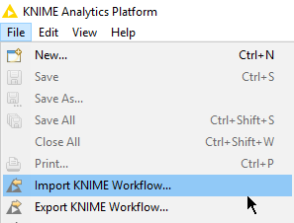

Under Source, select the packaged workflow P08_Starter.knwf, for Destination, select the folder where you usually store your workflows. Click Finish to import the workflow.

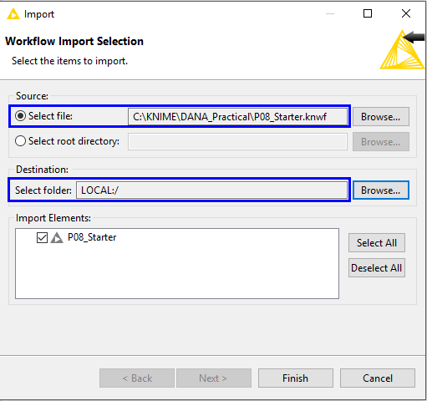

- K-Means Clustering
Double-click on the workflow in the explorer pane to bring up the workflow in the main canvas.

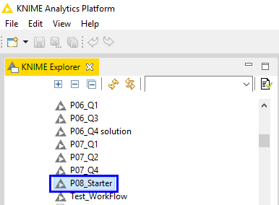

Your workflow should resemble the one shown below.

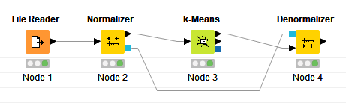

If File Reader node has a warning sign, you need to make sure that File Reader node points to the correct location of the Input file (Right-click configure Browse browse to correct location select song_data.csv).

Execute the node and look at the output in File Table.

 | Discussion: How many columns are there in total?  What are the range of values for key column?  What are the range of values for song_duration_ms column?
Answer:

Total number of columns = 15
Range of values for key column : 0 to 11
Range of values for song_duration_ms column : 12,000 to 1,800,000 (very big numbers)

Before doing k-Means clustering, it is a good idea to normalize the fields since this would reduce the effects of unequal ranges across the fields.

Right-click on the Normalizer node. Notice that only song_popularity is excluded (to be explained later). Notice also that we have used the default setting, i.e. Min-Max Normalization, where Min = 0.0 and Max = 1.0.
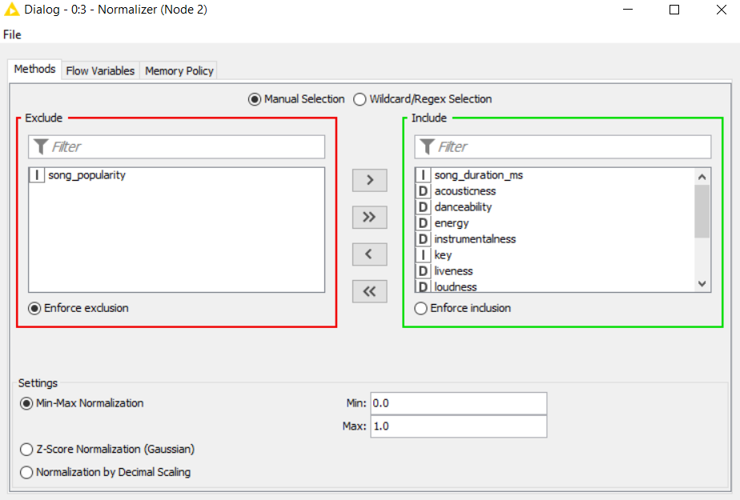
Execute this node and look at the output in Normalized Table.

 | Discussion:  What are the range of values for key column? Why?  What are the range of values for song_duration_ms column? Why?
Answer:

Range of values for key column : 0 to 1
Range of values for song_duration_ms column : 0 to 1.
The figures have been normalized to between 0 - 1 to facilitate k-means clustering downstream.

Double click on the k-Means node and look at its setting.
We have deliberately excluded the song_popularity since we want to see if we can group songs by their characteristics.

Set maximum number of iterations to be 500. The algorithm will quit if it has not found a stable solution after 500 iterations.

For centroid initialization, choose the option Random Initialization.
Check the box for use static random seed and set the seed to 12345. By doing so, it is possible to get reproducible results in subsequent runs.
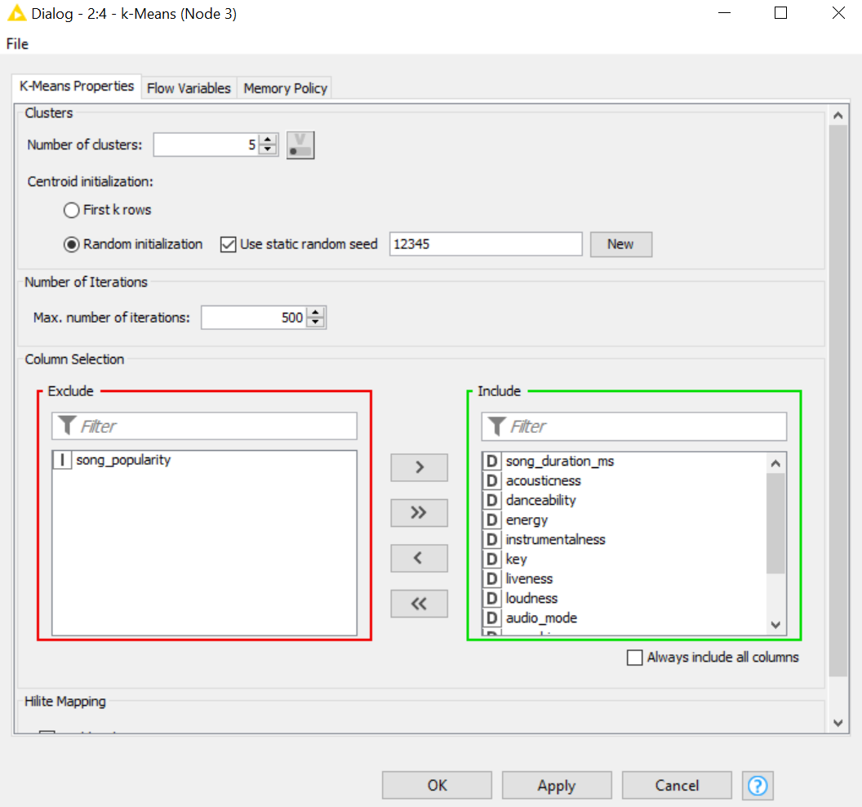

Execute the node and view the Labeled Input.
 | Discussion:  Do you see any difference in the output?
Answer:
There are now 16 columns, and at the far right, you should see a new column named Cluster, where each row is labelled as cluster_0, cluster_1, cluster_2, cluster_3 or cluster_4.

Let’s move on to the Denormalizer node. There is no need to configure. Execute the node and look at the output.
 | Discussion:  Do you see any difference in the output? What is the purpose of the Denormalizer node?
Answer:

Range of values for key column : 0 to 11
Range of values for song_duration_ms column : 12,000 to 1,800,000 (very big numbers)
Denormalizer node change the data back to the original measurement of scale.

- Numeric Binner
Add a Numeric Binner node downstream from the Denormalizer node.
We want to bin the song_popularity into 5 bins.

Select the song_popularity column.

Click on Add to add a new bin segment. Then click on Bin 1. Add Bin 2 in order to adjust the upper boundary of Bin 1. Edit the name of Bin 1 to Very Unpopular. Do the same for the next few bins.
(Note : You cannot adjust the lower boundary of the first bin and the upper boundary of the last bin).

Be sure to check the checkbox to Append new column .

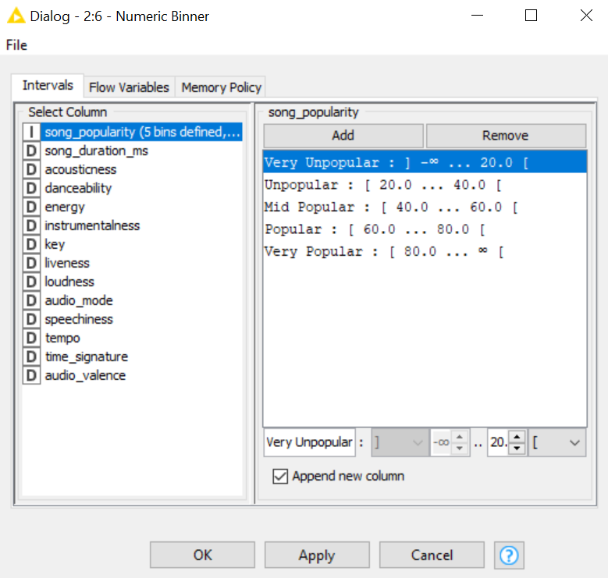

Go ahead and execute the workflow.
Verify that you now have a total of 17 columns, with two new columns (Cluster and song_popularity_binned) appended at the right.
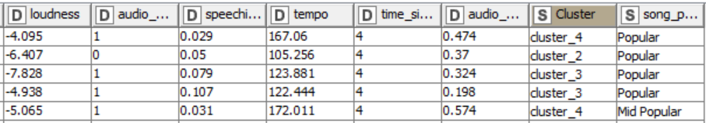
- We want to write this information into a file, so that we can then visualize it in our dashboard tool.

First, a cosmetic change, we want to capitalize the cluster ids. (from cluster_0, cluster_1, cluster_2 to Cluster_0, Cluster_1, Cluster_2).

Add a String Manipulation node downstream. Configure it as follows:
Expression: capitalize($Cluster$)
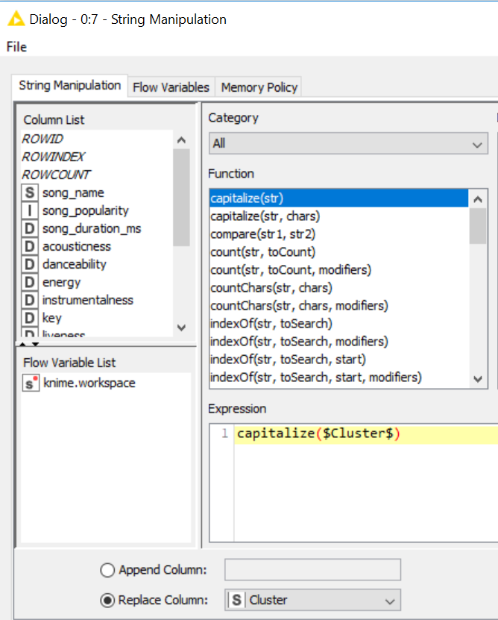
Select the option to replace the original Cluster column.

- Next add a CSV Writer node downstream, select an appropriate location / filename to write the table to.

Be sure to check the checkboxes to write the column header as well as the row ID. If file exists, overwrite it.

Execute the CSV Writer node, go to the location where you selected and verify that the csv file is created. Once you confirmed that file is there, you can go ahead and exit from KNIME. Take note of the file location, we will use this file in the next question.
- Re-cap KNIME Workflow for k-Means Clustering
Ask : Are the scale of measurement different across different fields?

What to exclude : The column you want to compare your resulting clusters against e.g. song_popularity
Min-Max Normalisation : Scale the range to between 0.0 to 1.0
If so, this will affect distance-based algorithms. Use this to reduce the effect of different ranges.
Decide : How many clusters (k) you want.
Behind the scene, k-Means clustering is performed iteratively using Euclidean distance.
Only numeric inputs will be used in k-Means clustering.

Ask : Which column do you want to compare with your resulting clusters?
e.g. song_popularity

This column will be excluded later.
This node outputs the position of the cluster centers for each of the k clusters.

This node also assigns each data point to exactly one cluster.

Undo the action of Normalizer node. Restores data values to the original form.

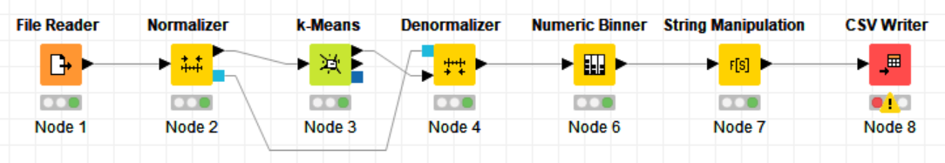
Cosmetic change only – capitalize Cluster
For visualisation purposes in Power BI later.

Group the column that you want to compare with the resulting clusters.

E.g. song_popularity will be grouped into 5 bins.

This is similar to Discretisation found in Practical 6.

Ask : Is there an association between each cluster and the binned song_popularity?

Ask : What are the characteristics of each cluster? (Cluster Profiling)

Question 2 (Visualizing the Clusters)
We will now read the CSV file prepared in Question 1 into Power BI desktop. This will allow us to prepare visualizations using stacked column chart, clustered bar chart, gauge chart and card visual.
In the process of exploring the data, we may be able to discover things such as:
- Can we group songs by their characteristics into groups?
- Does the grouping correspond to the popularity of songs?
- Are there any distinct features that determines if a song would be popular?

For Mac Users : Use Power BI Service
The column Song_duration_ms is supposed to be integer data type. But Power BI Service does not read in as a numeric data type. To get around this : Open .csv file Highlight the numeric values in the column for Song_duration_ms increase to 1 decimal place Save file

Sign in to Power BI Service (in the cloud) Click Get Data Click Get Under File Select Local File Navigate to P08.csv and select file. You should see the dataset P08.csv in Power BI Service. Click ⁞ next to P08.csv Select Create Report. A blank canvas will appear in Report View. You can then continue to the next exercise.

- Launch Power BI Desktop and get the csv file created from Question 1 by clicking File Get Data Text/CSV.

We will first create a stacked column chart.

Select to build a Stacked column chart.
- Select Cluster to be Axis
- Select song_popularity_binned to be Legend
- Select row ID to be Value make sure aggregation is Count

Click on the ellipsis at the bottom right corner of the visual.
Select Sort by > Cluster.

Click on the ellipsis again > Select sort by ascending order.

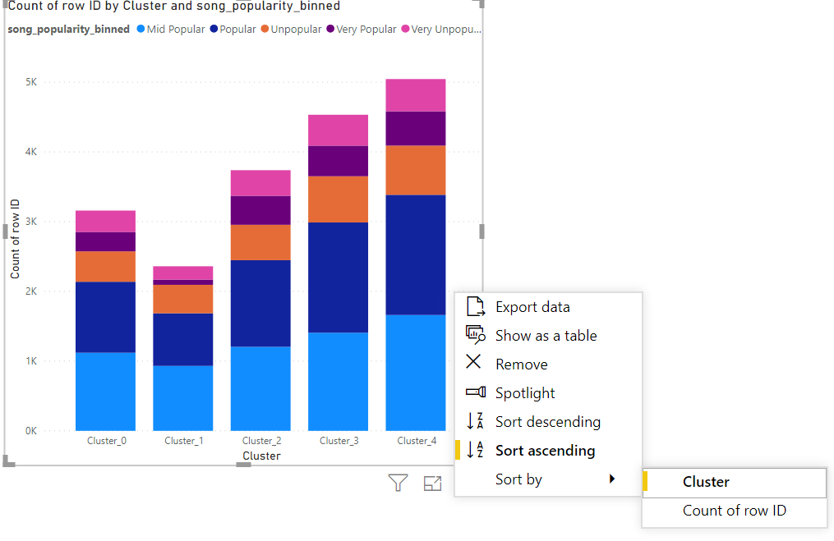
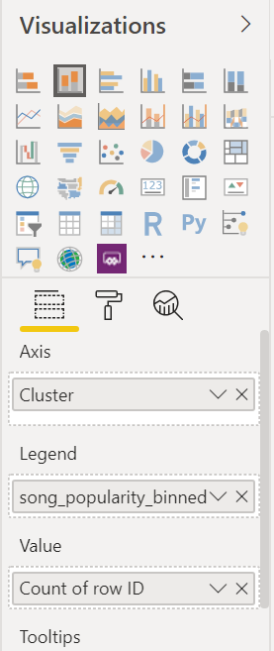

 | Question:  - Can we group songs by their characteristics into groups?  - Does the grouping correspond to the popularity of songs?
Answer: Yes. Clustering allows us to group the songs by their characteristics into 3 non-overlapping clusters

Based on the mixture of popularity for each cluster, the clusters do not match the popularity. There are other factors at play in determining if a song is popular. If clusters correspond nicely to popularity, each bar would only have one colour.

- Next, we will create a clustered bar chart.

Select to build a clustered bar chart (top row, 3rd from left viz).
- Add the following as Value
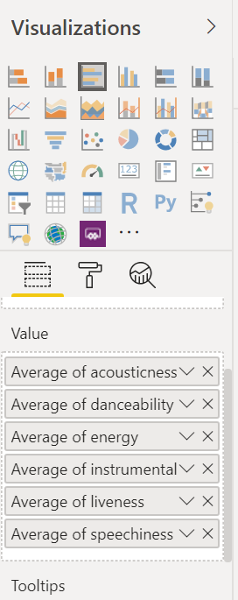
  - acousticness
  - danceability
  - energy
  - instrumentalness
  - liveness
  - speechiness
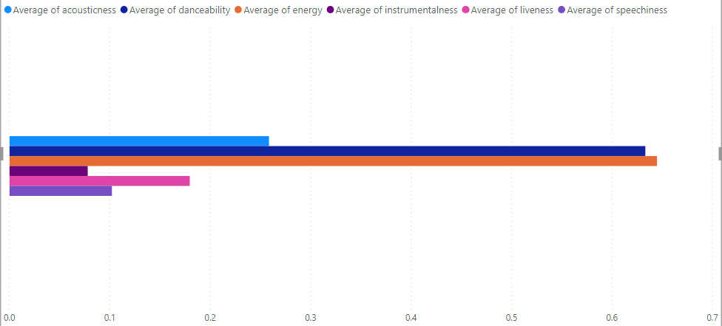
- Set aggregation method as Average

- Next, we will create a Gauge chart.
- Select Average of song_duration_ms to be Value
(right-click average)
- Select Min of song_duration_ms to be Minimum Value
(drag and drop song_duration_ms to value, right-click to select minimum)
- Select Max of song_duration_ms to be Maximum Value
(drag and drop song_duration_ms to value, right-click to select maximum)
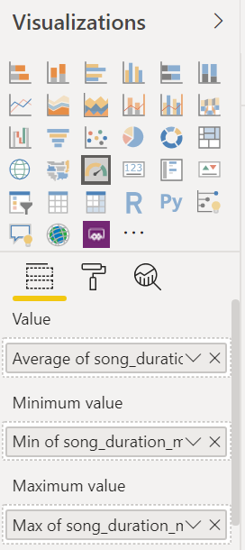
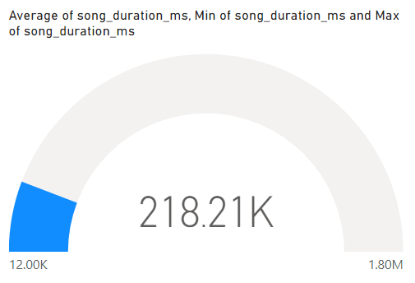

- Finally, let’s add 2 filters to our report.
For the first filter, drag and drop song_popularity_binned to the Add data fields here area.
For the second filter, drag and drop Cluster to the Add data fields here area.
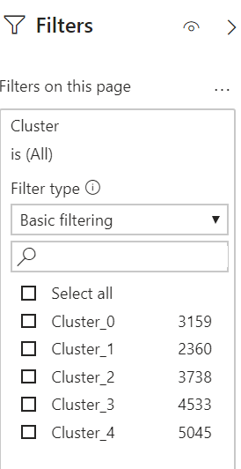
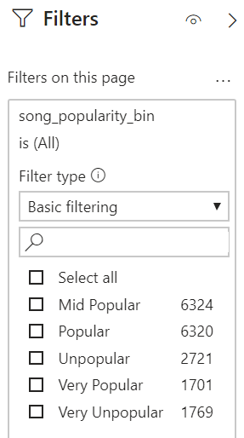

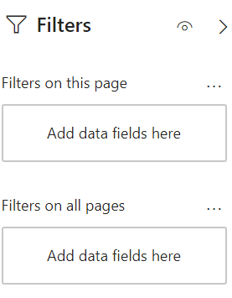

 | Question:  - Are there any distinct features that determines if a song would be popular?
Answer:

Save your report.
Question 3
- Explore how you can modify the filters so that you can select multiple values instead of only one value each time.

- Add a Card viz, set Value to be Average of song_popularity

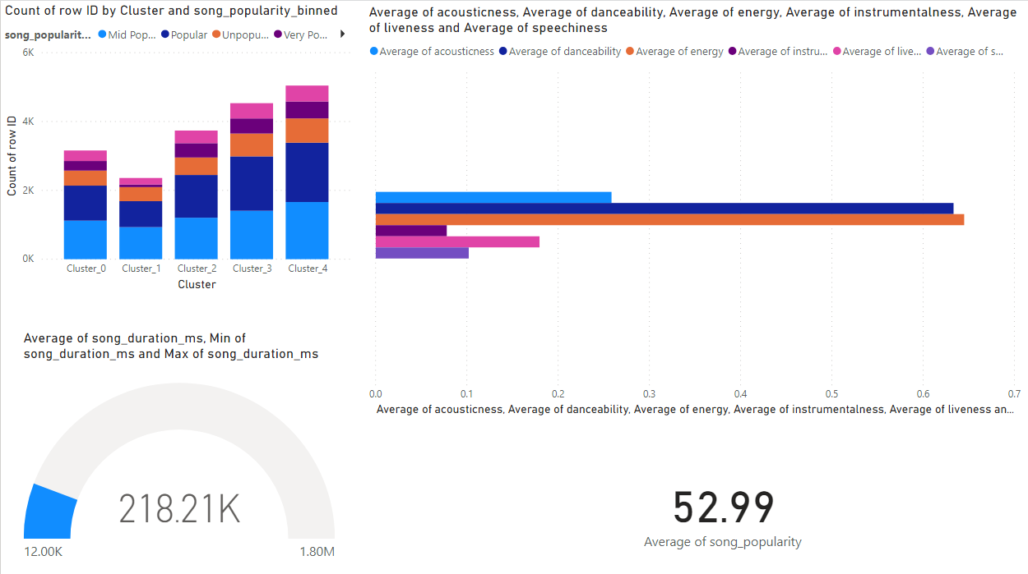
- Cluster Profiling (Important to know this!)
Using your dashboard, explore each cluster by filtering to only one cluster each time.
Write short notes about each cluster, are there any unique characteristics for songs in each cluster?
Cluster_0 : High danceability, and energy, not so high acousticness
Cluster_1 : Lower energy, very high acousticness
Cluster_2 : Generally slightly higher in all variables
Cluster_3 :
Cluster_4 :

- End of Practical 8 -

 | Summary
In this practical, we explored how we can bin data based on user-defined intervals. We also looked at how we can carry out clustering, an analytics process in which similar data points are automatically grouped into non-overlapping groups.

In this practical we made use of the following new nodes (not covered in previous practical) in KNIME.
Node |  | Purpose | Remarks
Normalizer |  | This node normalizes the values of numeric column. Scaling them such that the effects of different ranges are mitigated. | Read note documentation for the 3 normalization strategies.
k-Means |  | This node outputs the cluster centers for a predefined number of clusters.  K-means performs clustering that assigns each data point to exactly one cluster. The algorithm terminates when the cluster assignments do not change anymore. | The clustering algorithm uses the Euclidean distance on the selected attributes.  If required, you should consider using the "Normalizer" as a pre-processing step.
Denormalizer |  | Undo what the Normalizer node does and restores the data to its original value. | Nil.
Numeric Binner |  | Used for grouping numeric values into user defined intervals - known as bins.  User can provide unique name for each of these bins, define the range for each bin. | The square brackets are used to represent the interval borders (to include or exclude the value at bin borders).

